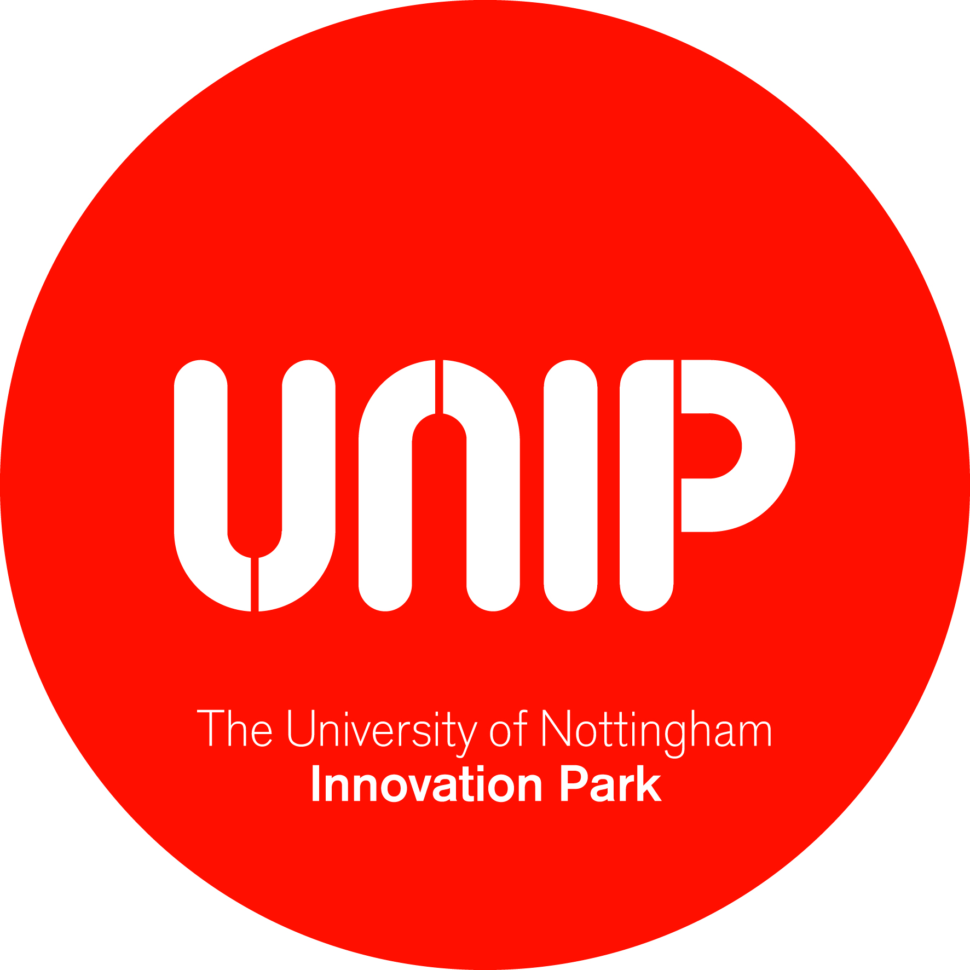

UNIVERSITY OF NOTTINGHAM INNOVATION PARK
RECRUITMENT ROLE PROFILE FORM

Job Title: UNIP Operations Director, UNIP Management Limited

Salary: £48,743 - £58,172 per annum, depending on skills & experience

Contract Status: This post will be offered on a permanent contract

Location: University of Nottingham Innovation Park

 | Main Responsibilities
1. | Development and delivery of UNIP strategy  The role holder will take the lead in evolving and implementing the strategy for further development and expansion of the Innovation Park, working closely with the Chair and Board members of UNIP Management Ltd, BEIS, and internal and external stakeholders.
2. | Overall responsibility for business development, operations, resourcing and management of UNIP Management Limited  The role holder will be accountable for all the activities of UNIP Management Ltd. Working to further develop the UNIP brand and profile through effective marketing and PR, they will proactively identify new business opportunities and build effective relationships across the region and beyond to contribute to UNIP’s success.  Through effective management of budgets and resources and identification of new income-generating opportunities, the Operations Director will secure the company’s financial sustainability, and will engage with and actively support developments within the University where these align with the goals of UNIP Management Ltd.
3. | Develop, implement and support business planning and commercial strategy decisions for specific next stage developments of UNIP  Working closely with senior University staff, the Operations Director will contribute to business planning for the next developments of the Innovation Park. They will represent UNIP in negotiating with external partners for new developments, and will actively participate in commercial decision-making processes.
4. | Support planning operations and optimal design for future buildings  Drawing on an in-depth understanding of UNIP’s business and its tenants’ needs, the Operations Director will provide high level advice and input to the design of future buildings. Working closely with University estates and facilities staff and external consultants, they will help to ensure that new developments are fit-for-purpose and commercially viable.
5. | Management of relationships with UNIP tenants: leases, licences, services  The Operations Director will have overall responsibility for managing the process of leasing and licencing UNIP facilities to tenants. They will champion the quality of service provided to UNIP’s tenants; setting priorities and service levels, implementing robust policies and procedures, and creating a culture of continuous improvement in service quality.
6. | Develop further strong linkages between the University’s research and teaching base and UNIP tenants  Working alongside BEIS, the Operations Director will act as a bridge between the University’s academic community and UNIP tenants; identifying and fostering opportunities for knowledge exchange. They will work with prospective and existing tenants of UNIP to create relationships for engagement and collaboration in research projects and other related research and teaching activities.
Working with the University’s campuses in China and Malaysia
The University is acknowledged as a leader in the internationalisation of higher education. The Operations Director will provide input and support to the planning, design and development of incubation and business accommodation facilities at the University’s campuses in China and Malaysia.
Operational management of the UNIP properties including staffing, event management and front-of-house services
With responsibility for a small team of administrative staff, the Operations Director will ensure the effective and efficient delivery of events and front-of-house services. This will include the development of relevant staffing policies and procedures as well as ensuring compliance with statutory reporting and other obligations on UNIP Management Limited.

Knowledge, Skills, Qualifications & Experience

 | Essential | Desirable
Qualifications/  Education | - Degree level (or equivalent) | - MBA (or equivalent)
Skills/Knowledge | - Proven business planning and operational planning skills  - Substantial understanding of contracts negotiation and management  - Proven project management skills  - Proven facilities management skills  - Substantial knowledge of budgetary and financial processes  - Well-developed understanding of regulations and legislation governing commercial lettings services  - Ability to work independently, maintaining high professional standards  - Strong leadership qualities, including the ability to motivate and inspire staff and lead as part of a team  - Excellent interpersonal, communication and presentation skills  - Excellent influencing, facilitating and negotiation skills and the ability to quickly establish and build relationships with all key stakeholders | - Understanding of University business engagement, knowledge exchange and commercialisation processes  - Proposal development and bid writing experience  - Understanding of property law
Experience | - Extensive relevant work experience including working at Board level  - Proven business development experience  - Substantial experience of managing partnership  - Proven people management experience | - Marketing  - Web authoring  - Event management  - Understanding of research culture in HE

Please send your CV along with a covering letter to sara.winskill-smith@nottingham.ac.uk.

Informal enquiries may be addressed to Mr Bob Scott, tel: 0115 823 2261 or email bob.scott@nottingham.ac.uk.

Please quote ref: UNIPM01

