We are looking for a talented & motivated scientist Early Stage Researcher to advance an exciting research project & undertake a fully funded PhD:

Early Stage Researcher (ESR11)
New pre-clinical screens in safety pharmacology
About INSPIRE – A European Training Network in Safety Pharmacology
The vision of INSPIRE is to advance and “inspire” Safety Pharmacology by exploring new technological capabilities to addressing emerging cardiovascular safety concerns. INSPIRE unites expertise from academic teams, technology-providers, pharmaceutical companies, regulators and hospitals to create a European Training Network for 15 Early Stage Researchers (ESRs). Key innovative aspects of INSPIRE include: i) in vitro humanized cardiomyocytes assays ii) unparalleled in vivo hardware/software solutions iii) in silico predictions of haemodynamics iv) mass spectroscopy imaging of drug exposure v) exploration of mechanisms of late-onset CV toxicity, as observed in cardio-oncology, and vi) early integration of feedback from industry and regulators.
INSPIRE constitutes a multidisciplinary Innovative Training Network (ITN) with a balanced combination of hands-on research training, intersectoral secondments, local courses and network-wide events on scientific and transferable skills, enabling future R&I collaborations. INSPIRE will equip the next generation of Safety Pharmacology scientists with a wide range of scientific knowledge and the ability to adapt to a dynamic industry.

Description of the PhD project
Scientific Objectives:  - Develop preclinical screens in safety pharmacology for detection of CV effects, using ‘failed’ clinical candidates.  - Utilise novel Doppler flowmetry models and telemetry to establish whether safety liabilities could have been predicted using more in-depth CV preclinical evaluations.  - Apply this information to investigate whether novel markers can be derived from the arterial pressure waveform that correlate to drug-induced effects at the vascular level. |  |  | 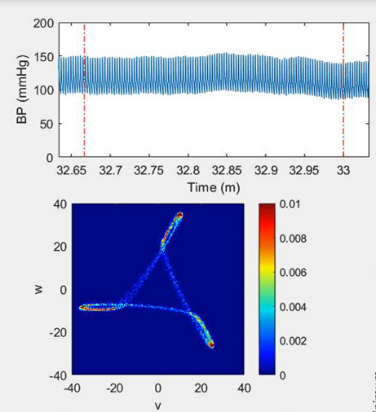
Tasks and Responsibilities:

- Perform independently scientific research within a collaborative international research consortium (training network).
- Deliver written reports of your research on a regular basis
- Prepare a doctoral thesis on the topic of arterial stiffness as potential marker for safety pharmacology.
- Publish scientific articles related to the research project of the assignment.
- Contribute to teaching activities if required by your PhD.
- Support the valorization of research results into tangible deliverables if required.
- Participate in scientific meetings and conferences to present your research to the scientific community.
- Actively participate in outreach activities aimed to promote your scientific research to a wider audience.
- Collaborate with the other members of the international consortium to maximise benefit from the tailored ESR training programme.
- Take part in at least the following planned secondments: 1. Industrial secondment to Vivonics (1 month) to learn about principles of GLP and workflows and a further 6 months for telemetry studies. 2. Industrial secondment to AstraZeneca (1 week) to visit facilities, establish collaborations.
About the University of Nottingham – Haemodynamics Research Group
The Haemodynamics Research Group (led by Prof. Jeanette Woolard) is embedded in the Faculty of Medicine and Health Sciences at the University of Nottingham. Her team collaborates with academic and industrial partners across the world, and is actively engaged with a number of centres of excellence, including COMPARE (Centre of Membrane Proteins and Receptors), the Centre of Biomolecular Sciences and Pain Centre Versus Arthritis. This research group has a track record in the field of cardiovascular pharmacology and physiology, such as examining the haemodynamic effects of anti-cancer therapies. More information about Prof Woolard and her team’s research interests are available at https://www.nottingham.ac.uk/life-sciences/people/jeanette.woolard. The University of Nottingham focuses on developing talented, passionate and dedicated people, as they strive to make important discoveries that have a real impact on lives and societies across the world. At the heart of that vision are the diversity of people attracted to our collaborative and inclusive research environment; supported and encouraged to realise their potential while delivering excellent research.
Profile & requirements
- Applicants must hold a MSc or equivalent in the field of Pharmacology, Physiology or Life Sciences.
- Applicants must have a solid knowledge of cardiovascular (patho)physiology and methods for investigating this.
- Applicants can be of any nationality, but have to comply with the “MSCA Mobility Rule ”.
- Applicants must have an ability to understand and express themselves in both written and spoken English to a level that is sufficiently high for them to derive the full benefit from the network training.
- Applicants must be eligible to enrol on a PhD programme at the host institution (or at a designated university, in case the host institution is a non-academic organisation).
- Applicants must have the necessary academic skills and background to make the success of a doctoral degree.
- H2020 MSCA Mobility Rule: researchers must not have resided or carried out their main activity (work, studies, etc.) in the country of the host organisation for more than 12 months in the 3 years immediately before the recruitment date. Compulsory national service, short stays such as holidays, and time spent as part of a procedure for obtaining refugee status are not taken into account.
- H2020 MSCA eligibility criteria: Early Stage Researchers (ESRs) must be, at the date of recruitment by the host organisation, in the first four years (full-time equivalent research experience) of their research careers and have not been awarded a doctoral degree. Full-Time Equivalent Research Experience is measured from the date when the researcher obtained the degree entitling him/her to embark on a doctorate (either in the country in which the degree was obtained or in the country in which the researcher is recruited, even if a doctorate was never started or envisaged).
Benefits
- The selected candidate will be employed by the recruiting beneficiary organisation for 36 months.
- A competitive salary plus allowances. Moreover, funding is available for technical and personal skills training and participation in international research events.
- The selected candidate will benefit from the designed training programme offered by the host organisation and the international INSPIRE consortium.
- The selected candidate will participate in international secondments to other organisations within the INSPIRE network and in outreach activities targeted at a wide audience.
Please, find additional information in the Information note for Marie Skłodowska-Curie ITN fellows
Application
Interested candidates are invited to apply for this position by filing in the application form on our website (www.inspire-safety-pharmacology.eu), via this link: https://www.uantwerpen.be/en/projects/inspire-safety-pharmacology/job-openings/submit-your-applicat/ .
For additional information
Prof. Jeanette Woolard
Email: jeanette.woolard@nottingham.ac.uk
Phone: +44 (0)115 823 1481

